The Articles of Confederation
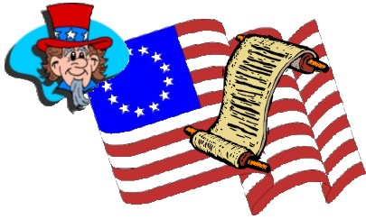
The Continental Congress wrote the Articles of Confederation during the Revolutionary War. The articles were written to give the colonies some sense of a unified government. Once the thirteen colonies became the thirteen states, however, each one began to act alone in its own best interest. A new governing document was needed in order for these new states to act together, to become a nation.
The Articles of Confederation became effective on March 1, 1781, after all thirteen states had ratified them. The Articles made the states and legislature supreme. There was no executive branch. Judicial functions were very limited.
The resulting government was weak. Efforts to make it stronger failed. A convention called in May 1787 to re-write the Articles decided to draft an entirely new Constitution.

Strengths ____________________________________________ __________________________________________________________________________________________________________
Weaknesses____________________________________________________________________________________________________________________________________________________________
The Work Begins
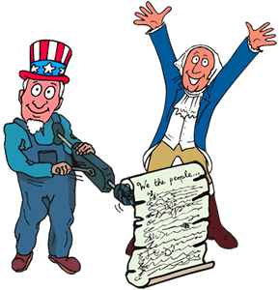
The writers of our Constitution wanted to make sure that the new nation and its citizens would be free and independent. They wanted to make sure that the government of the United States would protect the people from a government that was too powerful and from the autocratic rule of kings. They didn't want the wishes of the people to be denied by any part of government or by the power of any single leader. But they also knew the government must be stronger than the one based on the Articles of Confederation. So the writers of the Constitution planned a very special kind of government and put their plan in writing.
George Washington had won the respect of his countrymen as commander of the Continental Army. Washington's fellow delegates elected him president of the Constitutional Convention because they held him in high esteem.
As president of the Constitutional Convention, Washington's job was to keep the meetings orderly and effective. This was no small task considering the many different points of view among the delegates. The delegates listened carefully when President Washington broke in to make a contribution.
Before the Constitutional Convention began, a rules committee decided how the process would work. No matter how many delegates a state sent, each state was given only one vote. If a state sent more than one delegate, all delegates had to come to an agreement about their state's one vote. Any delegate could voice an opinion. All proceedings would be kept secret until the Constitutional Convention presented a finished Constitution.

The Great Compromise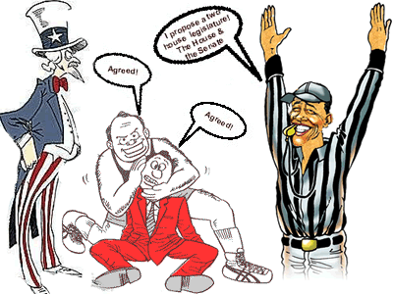
Delegates to the Constitutional Convention came from different backgrounds and held different political views. For example, they argued about how many representatives each state should be allowed. The larger states favored the Virginia Plan. According to the Virginia Plan, each state would have a different number of representatives based on the state's population. The smaller states favored the New Jersey Plan. According to the New Jersey Plan, the number of representatives would be the same for each state.
A delegate from Connecticut, Roger Sherman, proposed a two-house legislature, consisting of a Senate and a House of Representatives. The Senate would have an equal number of representatives from each state. This would satisfy the states with smaller populations. The House of Representatives would include one representative for each 30,000 individuals in a state. This pleased states with larger populations.
This two-house legislature plan worked for all states and became known as the Great Compromise.

The Bill of Rights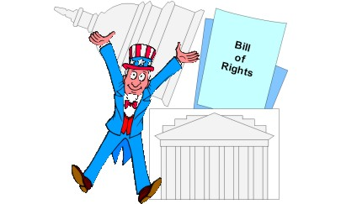

Some delegates, however, would not approve the Constitution when it was sent to the states for ratification until it included a bill of rights listing the individual rights of every citizen. So, the Convention promised a bill of rights would be attached to the final version. Several amendments were immediately considered when the first Congress met in 1789. Twelve amendments, written by James Madison, were presented to the states for final approval. Only ten were approved. Those ten make up the Bill of Rights. They are also the first ten amendments to the Constitution.
Powers of the Federal Government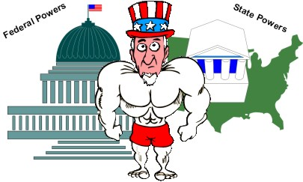
Once ratified, the Constitution set the basis for the government we have today. Powers are divided between the federal (or national) government and the 50 states. The Founding Fathers knew they had to leave enough powers with the states when they were writing the Constitution. If they didn't, they knew the state legislatures would never ratify the Constitution. All states were granted the right to control certain things within their borders. They could do so as long as they did not interfere with the rights of other states or the nation.

The Three Branches of Government
Delegates at the Constitutional Convention also wanted to divide power within the federal government. They did not want these powers to be controlled by just one man or one group. The delegates were afraid that if a small group received too much power, the United States would wind up under the rule of another dictator or tyrant.
To avoid the risk of dictatorship or tyranny, the group divided the new government into three parts, or branches: the executive branch, the legislative branch, and the judicial branch.
Executive Branch: Headed by the president. The president carries out federal laws and recommends new ones, directs national defense and foreign policy, and performs ceremonial duties. Powers include directing government, commanding the Armed Forces, dealing with international powers, acting as chief law enforcement officer, and vetoing laws.
Legislative Branch: Headed by Congress, which includes the House of Representatives and the Senate. The main task of these two bodies is to make the laws. Its powers include passing laws, originating spending bills (House), impeaching officials (Senate), and approving treaties (Senate).
Judicial Branch: Headed by the Supreme Court. Its powers include interpreting the Constitution, reviewing laws, and deciding cases involving states' rights.

Checks and Balances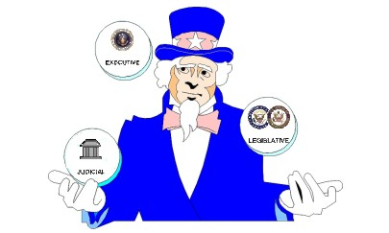By creating three branches of government, the delegates built a "check and balance" system into the Constitution. This system was built so that no one branch of our government could become too powerful.
Each branch is restrained by the other two in several ways. For example, the president may veto a law passed by Congress. Congress can override that veto with a vote of two-thirds of both houses. Another example is that the Supreme Court may check Congress by declaring a law unconstitutional. The power is balanced by the fact that members of the Supreme Court are appointed by the president. Those appointments have to be approved by Congress.
Amendments
Very few things last long without change. Nothing is perfect. The writers of the Constitution realized this when they presented the first twelve amendments to the Constitution.
Amendments to the Constitution can be either additions or changes to the original text. It is not easy to change the Constitution. Since 1787, over 9,000 amendments have been proposed, but only 27 have been approved.

NOTES:________________________________________________________________________________________________________________________________________________________________________________________________________________________________________________ _________________________________________

